**JAVA WEEK 2 DAY 1 GiT**

  Git is a modern and widely used **distributed version control system** in the world. It is developed to manage projects with high speed and efficiency. The version control system allows us to monitor and work together with our team members at the same workspace.

Git is an open-source distributed version control system. It is designed to handle minor to major projects with high speed and efficiency. It is developed to co-ordinate the work among the developers. The version control allows us to track and work together with our team members at the same workspace.

**WHAT IS GIT**

Git is an open-source distributed version control system. It is designed to handle minor to major projects with high speed and efficiency. It is developed to co-ordinate the work among the developers. The version control allows us to track and work together with our team members at the same workspace.

Git is foundation of many services like GitHub and GitLab, but we can use Git without using any other Git services. Git can be used privately and publicly.

Git was created by Linus Torvalds in 2005 to develop Linux Kernel. Git is easy to learn, and has fast performance. It is superior to other SCM tools like Subversion, CVS, Perforce, and ClearCase.

**BENEFIT OF USING GIT**

**Benefits of using Git**

A version control application allows us to **keep track** of all the changes that we make in the files of our project(s). Every time we make changes in files of an existing project, we can push those changes to a repository.

Other developers are allowed to pull your changes from the repository and continue to work with the updates that you added to the project files.

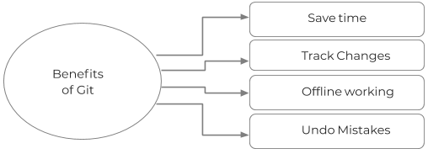

***Benefits of git***

Major benefits of Git are:

**Saves Time**

Git is lightning fast technology. Each command takes only a few seconds to execute so we can save a lot of time as compared to login to a GitHub account and find out its features.

**Offline Working**

One of the most important benefits of Git is that it supports offline working. If we are facing internet connectivity issues, it will not affect our work. In Git, we can do almost everything locally. Comparatively, other CVS like SVN is limited and prefer the connection with the central repository.

**Undo Mistakes**

One additional benefit of Git is we can Undo mistakes. Sometimes the undo can be a savior option for us. Git provides the undo option for almost everything.

**Track the Changes**

Git facilitates with some exciting features such as Diff, Log, and Status, which allows us to track changes so we can check the status, compare our files or branches.